Chapter 9, Solution 26.

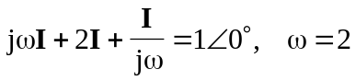
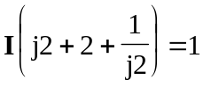
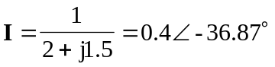
Therefore, i(t) = 0.4 cos(2t – 36.87)

